**Notes in Module 6 Youtube**

https://www.youtube.com/watch?v=GNyvRP6HzhA&feature=youtu.be

**How computers think (procedurally)**

1. Evert problem in software development begins with a **complex and abstract real-world problem**

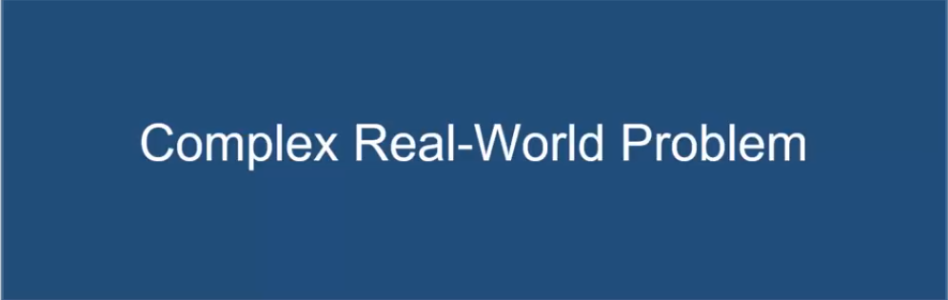

1. In order for computers to handle things, this “real world” problem needs to be broken down into a set of discreet procedural steps.

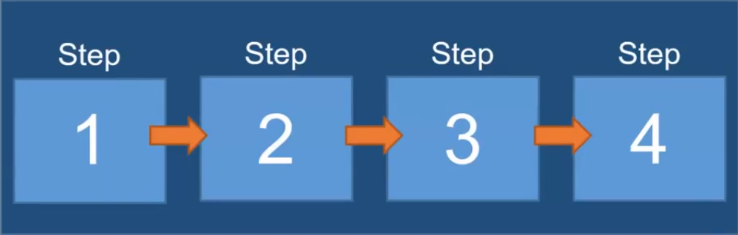

1. Procedural programming may be the basics of programming, but having to wait for one step to finish before beginning another is not the most efficient way to program.

**Common Structures in nearly all programming languages**

1. Variables

* Items needed in a procedure
* Can be physical things like ingrediencies or abstract things like a counter
* JavaScript - declared by using the var key word:

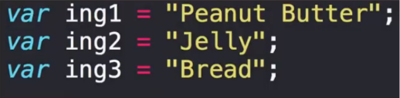

1. Arrays

* Collection of related items
* Another way to store and reference like pieces of information
* JavaScript - declared by using the var keyword and information enclosed in brackets [], divided by comma , :



1. Conditionals

* Presents a way to control the floe of logic based on certain condition being met.
* JavaScript – uses if/ else statements:

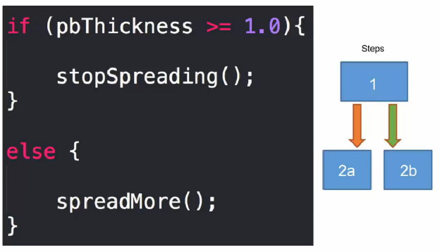

( look in to ternary operator: pbThickness >= 1.0 ? stopSpreading() : spreadMore(); )

1. Iterations

* The concept of using loops to preform a group of tasks repeatedly for a # of times:
* JavaScript – For-loops & While-lopps:

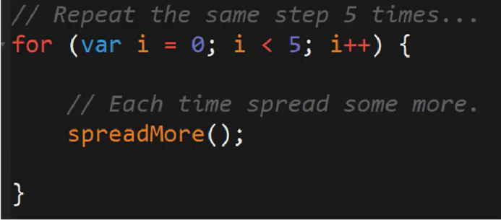

(Combination of Variables, Conditionals, Iterations)

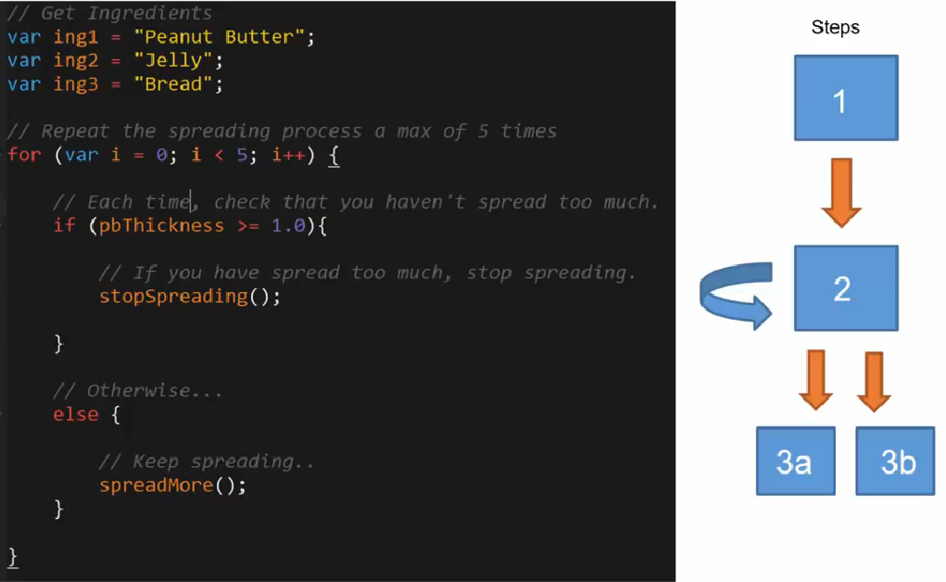

1. Functions

* The sub-processes, that allow us toe create pre-made, reusable blocks of codewhich can be called on demand (ie. The blueprint)
* Run Asynchronously (
* JavaScript – Function name(parameters) { code is here }

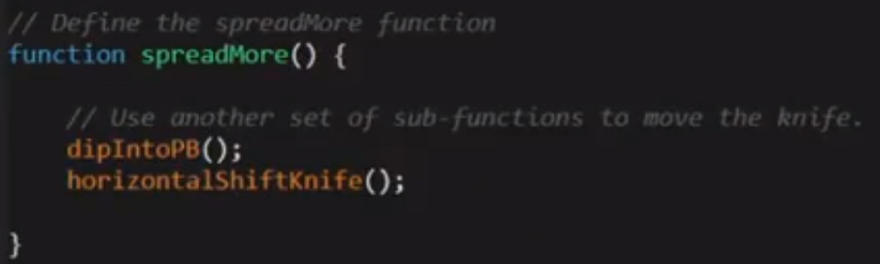

**Codes to make a Sandwich:**

